# Models, Agent-based Models, and the Modeling Cycle



Figure 1.1. Flight path of a female wandering albatross (*Diomedea exulans*) feeding in the southern Indian Ocean. The flight begins and ends at a breeding colony (indicated by the star) in the Crozet Islands. Data recorded by H. Weimerskirch and colleagues for studies of adaptive search behavior in albatross (e.g., Weimerskirch et al. 2007).

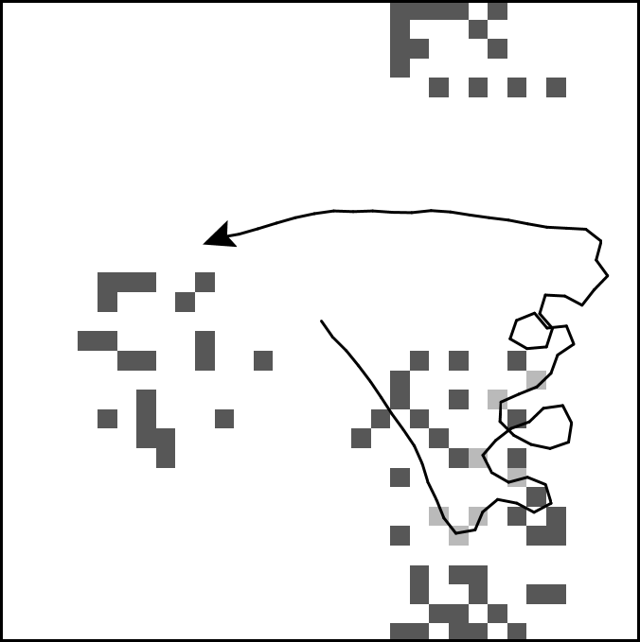

Figure 1.2. Path of a model agent searching for items that are distributed in clusters.

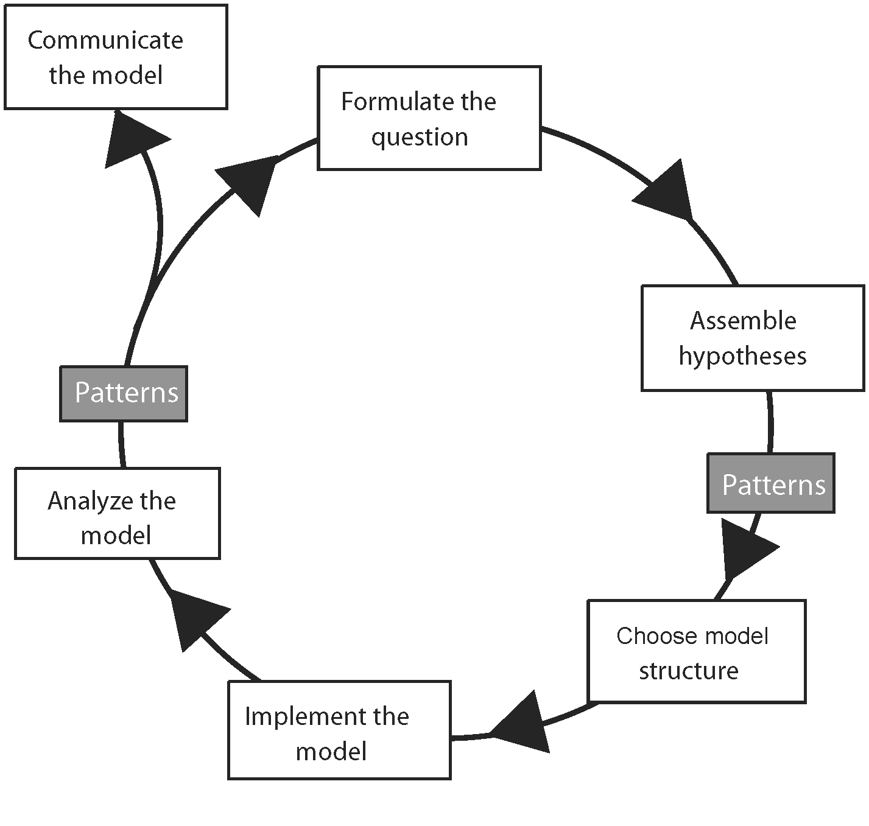

Figure 1.3. The modeling cycle. (From Grimm and Railsback 2005.)

# Getting Started With NetLogo



Figure 2.1. Adding a button to the Interface.



Figure 2.2. Starting to write code in the Procedures tab.



Figure 2.3. Mushroom Hunt interface with the model initialized.



Figure 2.4. Giving a command to all turtles via the Command Center.

# Describing and Formulating ABMs: The ODD Protocol

|  |  |
| --- | --- |
|  | **Elements of the ODD protocol** |
| **Overview** | 1. Purpose and patterns |
| 2. Entities, state variables, and scales |
| 3. Process overview and scheduling |
| **Design concepts** | 4. Design concepts   * Basic principles * Emergence * Adaptation * Objectives * Learning * Prediction * Sensing * Interaction * Stochasticity * Collectives * Observation |
| **Details** | 5. Initialization |
| 6. Input data |
| 7. Submodels |

Figure 3.1. Overview of the ODD protocol for describing ABMs (as described by Grimm et al. 2010).

Table 3.1. Design concepts for ABMs, with key questions for an ODD description to answer.

|  |  |
| --- | --- |
| Concept | Key questions |
| Basic principles | 1. What general concepts, theories, hypotheses, or modeling approaches underlie the model’s design? How is the model related to previous thinking about the problem it addresses?  2. How were these principles incorporated in the model’s design? Does the model implement the principles in its design, or address them as a study topic, e.g., by evaluating and proposing alternatives to them? |
| Emergence | 3. What are the model’s important results and outputs? Which of them emerge from mechanistic representation of the adaptive behavior of individuals, and which are imposed by rules that force the model to produce certain results? |
| Adaptation | 4. What adaptive behaviors do agents have, and why? In what ways can they respond to changes in their environment and themselves? What decisions do they make?  5. How are these behaviors modeled? Do submodels of adaptive behavior assume agents choose among alternatives by explicitly considering which is most likely to increase some specific objective (direct objective-seeking), or do they simply force agents to reproduce behavior patterns observed in real systems (indirect objective-seeking)? |
| Objectives | 6. For adaptive behaviors modeled as direct objective-seeking, what measure of agent objectives (for example, “fitness” in ecology, “utility” in economics) is used to rate decision alternatives? This objective measure is the agent’s internal model of how it would benefit from each choice it might make. What elements of future success are in the objective measure (e.g., survival to a future reproductive period; probability of staying in business for some period; profits at the next reporting period)? How does the objective measure represent processes that link adaptive behaviors to important variables of the agents and their environment?  7. How were the variables and mechanisms in the objective measure (e.g., risks of mortality or going out of business, the conditions necessary for reproduction or profitability) chosen, considering the model’s purpose and the real system it represents? How is the agent’s current internal state considered in modeling decisions? Does the objective measure change as the agent changes? |
| Learning | 8. Do individuals change how they make adaptive decisions over time as a consequence of their experience? If so, how? |
| Prediction | 9. How do agents predict future conditions (environmental and internal) in their submodels for adaptive behavior? What assumptions about, or mechanisms of, the real individuals being modeled were the basis for how prediction is modeled?  10. How does simulated prediction make use of mechanisms such as memory, learning, or environmental cues? Or is prediction “tacit,”i.e., only implied in simple rules for adaptive behavior? |
| Sensing | 11. What variables of their environment and themselves are agents assumed to sense and therefore be able to consider in their behavior? What is the basis for these assumptions?  12. What sensing mechanisms are modeled explicitly, and which sensed variables are agents instead assumed simply to “know”?  13. With what accuracy or uncertainty are agents assumed to “know” or sense which variables? Over what distances (in geographic, network, or other space)? |
| Interaction | 14. How do the model’s agents interact? Do they interact directly with each other (e.g., does one agent directly change the state of others)? Or is interaction mediated, such as via competition for a resource?  15. With which other agents does an agent interact?  16. What real interaction mechanisms were the model’s representation of interaction based on? At what spatial and temporal scales do they occur? |
| Stochasticity | 17. How are stochastic processes (based on pseudorandom numbers) used in the model and why? Are stochastic processes used: To initialize the model? Because it is believed important for some processes to be variable but unimportant to represent the causes of variability? To reproduce observed behaviors using empirically determined probabilities? |
| Collectives | 18. Are collectives—aggregations of agents that affect the state or behavior of member agents and are affected by their members—represented in the model?  19. If so, how are collectives represented? Do they emerge from the behaviors of agents, or are agents given behavior submodels that impose the formation of collectives? Or are the collectives modeled as another type of agent with its own behaviors and state variables? |
| Observation | 20. What outputs from the model are needed to observe its internal dynamics as well as its system-level behavior? What tools (graphics, file output, data on individuals, etc.) are needed to obtain these outputs?  21. What outputs and analyses are needed to test the model against the criteria for usefulness—usually, a set of patterns—defined in the “Purpose and patterns” element? What outputs are needed to solve the problem the model was designed for? |



Figure 3.2. The butterfly movement action. A butterfly moves to one of its eight neighboring patches. Each patch has an elevation variable, displayed here in their upper left corners. If a random number is less than *q*, the butterfly moves to the neighbor patch with highest elevation, indicated by the arrow. Otherwise, the butterfly chooses one of the eight neighbor patches randomly.

# Implementing A First Agent-Based Model



**Figure 4.1. The Butterfly model’s artificial landscape.**



Figure 4.2. Interface of the hilltopping Butterfly model’s first version, with *q* = 0.4.

# From Animations To Science



Figure 5.1. The measure of corridor width for a group of uphill-migrating butterflies (here, 500 butterflies that started at location 68,65 with *q* = 0.4). Corridor width is (a) the number of patches used by any butterflies (the white patches here), divided by (b) the average straight-line distance (in units of patch lengths) between butterflies’ starting patch and ending hilltop. Here, most butterflies went up the two lower hills, but some went up the upper hills. The number of white patches is 4266 and the mean distance between starting point (the black dot) and ending points for all butterflies is 62.0 patches; hence, corridor width is 68.8 patches.



Figure 5.2. An output window displaying corridor width.



Figure 5.3. Corridor width of the Butterfly model, using the topography and start patch in Figure 5.1, as a function of the parameter *q*. Points are the results of one simulation for each value of *q*.



Figure 5.4. How corridor width changes during simulations, for five values of *q*. Each line is output from one model run.

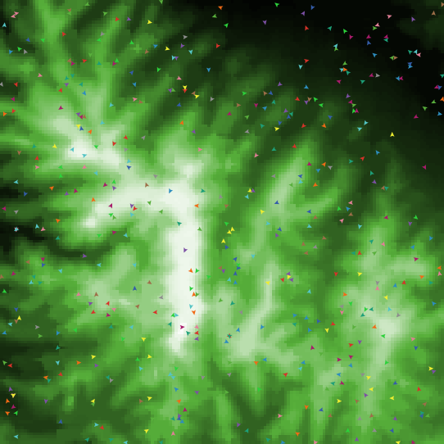 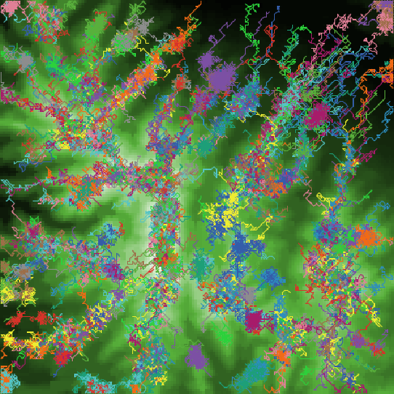

Figure 5.5. Topography of a real landscape showing (left) butterfly starting locations and (right) virtual corridors that emerged from movement behavior and topography with *q* = 0.4.

# 

# Testing Your Program

 

Figure 6.1. The agentset produced by the statement turtles-on patches in-radius 2 is quite different if the statement is executed by the center patch (left panel: all turtles in white patches are in the agentset) instead of by a turtle (the large black one) in the same center patch (right panel: again, all turtles in white patches are in the agentset).

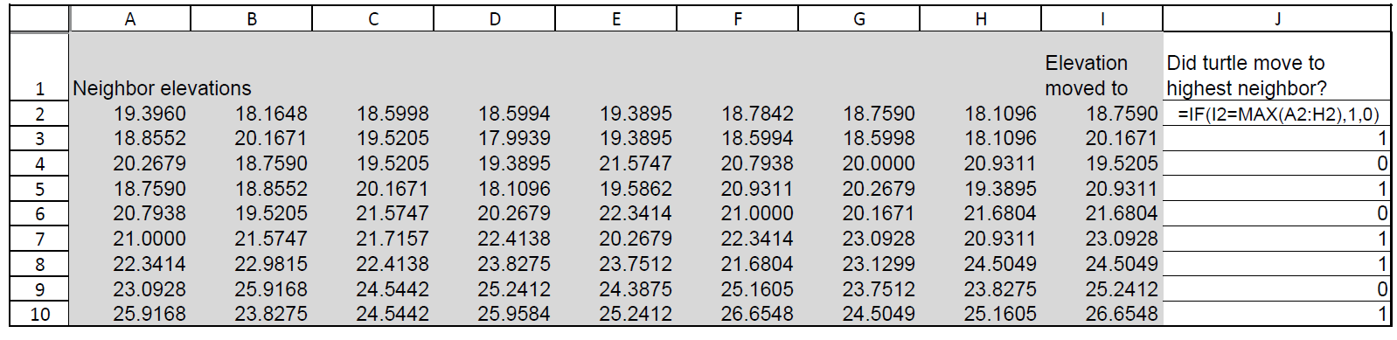

Figure 6.2. The first few lines of a spreadsheet used to analyze file output from the Butterfly model. Columns A-I were produced by the NetLogo program’s file output statements: columns A-H are the elevations of the eight neighbor patches before the turtle moves, and column I is the elevation of the patch that the turtle then moved to. Column J contains a formula that produces a 1 if the turtle’s new patch is the highest of its neighbors and a 0 if not (this formula is displayed in cell J2). Now the mean of column J is the fraction of moves that were to the highest neighbor patch, which can be compared to the predicted value of *q* + (1-*q*)/8.

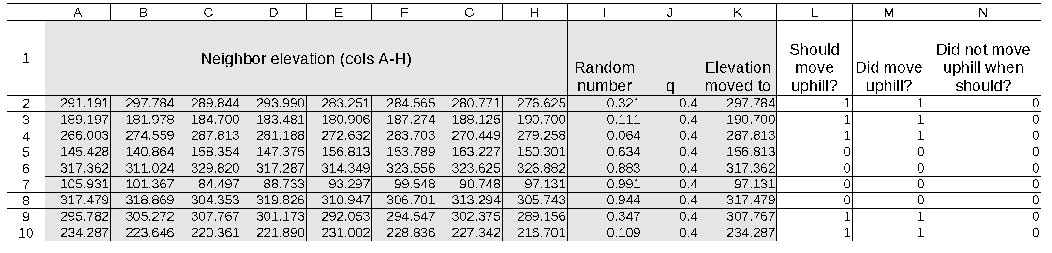

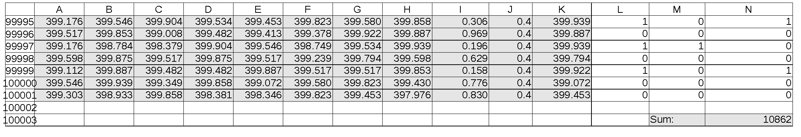

Figure 6.3. A spreadsheet reimplementation of the decision whether to move uphill in the Butterfly model. Columns A–K are output produced by the NetLogo code presented in the text. Column L reimplements the decision: it reports a 1 if the random number was less than *q* so the butterfly should move to the highest neighbor patch. Column M reports whether the butterfly actually did move to the highest neighbor. Column N reports a 1 if there is a discrepancy: if column L is 1 but the butterfly did not move to the highest neighbor patch. Keep in mind that (a) butterflies at the edge of the space would have fewer than eight neighbors, so the spreadsheet would need modification, and (b) column M will sometimes be 1 when column L is 0 because the highest neighbor can be chosen randomly. All the values in column N are summed at cell N100003. Because this sum is not zero, we know that there were discrepancies; here, 10,862 butterfly moves out of 100,000 were not correct.

# Introduction to Part II

Table 7.1.

|  |  |  |  |
| --- | --- | --- | --- |
| Chapter | Conceptual topics | Modeling topics | NetLogo and software topics |
| 8: Emergence | Which model results emerge in complex ways from agent behaviors, and which are instead relatively imposed and predictable? | Designing and analyzing simulation experiments | BehaviorSpace |
| 9: Observation | What outputs and displays are needed to understand and test an ABM? How do we compare model results to observed patterns? | Types of output: animation, plots, file | Obtaining information from the View, using plots and other Interface elements, writing output files |
| 10: Sensing | What information do agents use, and how do they obtain it? | How the extent over which agents sense information affects model results | The scope of NetLogo variables, obtaining and changing variables of other objects, writing reporters, using links |
| 11: Adaptive Behavior and Objectives | What decisions do agents make in response to changes in their environment and themselves? What measure of their objectives (fitness, utility, etc.) do agents use to make decisions? | Optimization and satisficing methods for decision-making | Identifying and subsetting agentsets, identifying optimal members of agentsets |
| 12: Prediction | What predictions do agents make in their adaptive behavior? | Independent testing and analysis of submodels, Bayesian updating as a model of prediction | Contour plotting in Excel or other platforms |
| 13: Interaction | How do agents interact with each other, either directly or indirectly via mediating resources? | Modeling competition via a shared resource, effects of global vs. local interaction, modeling memory | Modeling persistent interactions using variables for another agent, using lists |
| 14: Scheduling | How is time represented? How does the order in which actions are executed affect results? | Modeling time via discrete time steps vs. discrete events in continuous time, using sorted vs. unsorted execution to represent hierarchical or nonhierarchical systems, synchronous vs. asynchronous updating, stopping rules | The go procedure, controlling the order in which actions are executed and the order in which agents execute an action, loops, noninteger ticks |
| 15: Stochasticity | When should processes be modeled as if they are random? What stochastic functions are appropriate for such processes? | Replication experiments to determine the effects of randomness, common discrete and continuous random number distributions | Random number primitives, writing reporters, using BehaviorSpace to replicate experiments, defensive programming |
| 16: Collectives | Are there intermediate levels of organization: aggregations of individuals that affect the population and the individuals? How should such collectives be modeled? | Representing collectives as emergent characteristics of agents and as a separate type of agent, logistic functions to represent probabilities, stochastic models of behavior that use observed frequencies as probabilities | Breeds to represent multiple kinds of agents; representing collectives as patches, via links, or as a separate breed |

# Emergence

Fig8-1_BlankGraph

Figure 8.1. The problem we address with the Simple Birth Rates model: what shape will this graph have?



Figure 8.2. Experiment setup for the Simple Birth Rates experiment.

Fig8-3_BirthRatesResults

Figure 8.3. Example results of the Simple Birth Rates experiment. The dots are the mean time to red extinction, and error bars are +/- one standard deviation over the 10 replicates.



Figure 8.4. Experiment setup for Flocking.

Fig8-5a_FlockmatesResults

Fig8-5b_HeadingSDResults

Figure 8.5. Results from Flocking experiment for (top) mean number of flockmates and (bottom) standard deviation of turtle headings. The solid lines are the mean, and dotted lines +/- one standard deviation, over 10 replicates.

Fig8-6_1-FlockmateHeadings

Figure 8.6. Flocking results for standard deviation in heading, with turtles using only one flockmate.

# 

Figure 8.7. Illustration of vision angle; in this case the turtle can “see” 60 degrees both left and right of straight ahead.

# Observation



Figure 9.1. An interface monitor set up to display mean butterfly elevation.

# Sensing





Figure 10.1. Example results of the Business Investor model. Upper panel: How the final mean and standard deviation of investor wealth varies with their sensing radius. Lower panel: How mean investor wealth changes over simulated time for 5 values of sensing radius. Both graphs show mean results from 10 replicates of each sensing radius.

# Adaptive Behavior And Objectives





Figure 11.1. Results of an experiment varying the range of business profits. Top panel: The average final investor wealth as profits were varied from 0.5 to 1.0 of baseline. Bottom panel: Mean annual profit (left axis) and mean annual risk (right axis) of patches chosen by investors, over all years, for the same scenarios as in the top panel. Dots are the mean of all investors over 10 replicates of each scenario.





Figure 11.2. Results of varying the range of investment risk. Top panel: The average final wealth as risk varied from 1.0 to 2.0 times the baseline. Bottom panel: Mean annual profit (left axis) and mean annual risk (right axis) of patches chosen by investors, over all years. Dots are the mean of all investors over 10 replicates of each scenario.

# Prediction





Figure 12.1. Sensitivity of Business Investor model results to the decision time horizon. Each dot is the result at the end of a 50-year simulation. The time horizon was varied from 1 to 25 years. Symbols and error bars represent the mean and standard deviation over 10 replicates of each time horizon scenario. Top left: Mean wealth of investors. Top right: The number of business failures over the model run. Lower panels: Mean profit (left) and risk (right) of patches occupied by investors at the end of the model run.



Figure 12.2. Change over time in the mean annual risk of the businesses chosen by investors (in NetLogo, mean [annual-risk] of turtles, where annual-risk is the patch variable for risk).

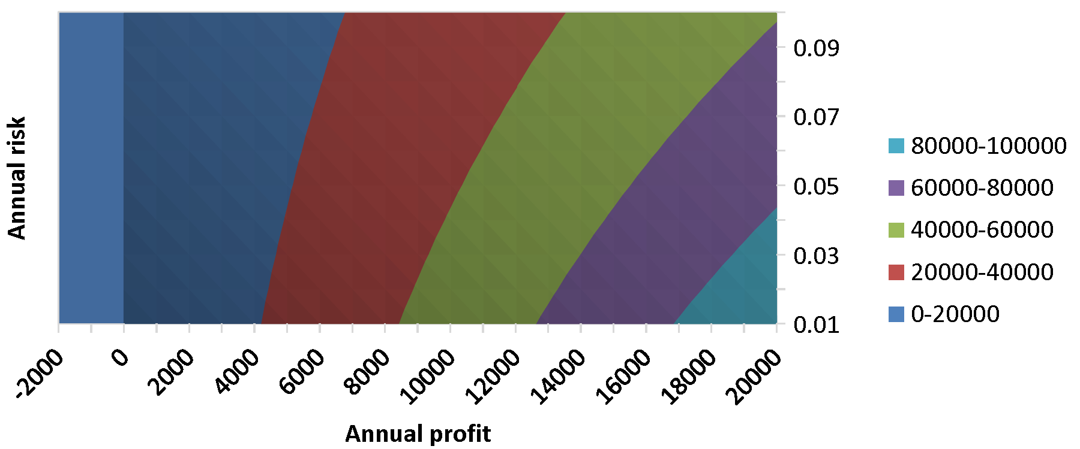

Figure 12.3. Contour plot of investor utility (defined in the *Objective* “Design concepts” element of section 10.4.1) when the investor’s current wealth is 0 and the time horizon is 5 years. Each band is a range of utility values; the borders between bands are “contour lines” of equal utility. Utility is highest in the lower right corner.



Figure 12.4. Spreadsheet implementation of the utility function. For each value of profit from −2000 to 20,000 (column A), there are 10 values of risk in column B. The formulas for columns C–E are shown in row 5. Lines 16–228 are not shown.



Figure 12.5. Utility function programmed in Excel in matrix format (with columns F–W hidden). Patch annual profit values increase from −2000 to 20,000 in columns C–Y; annual risk values increase from 0.01 to 0.1 in rows 6–15. Row 4 calculates investor wealth at the end of the time horizon. Column A calculates the probability of not having a failure over the time horizon. The contour plot in figure 12.3 is drawn by selecting cells B5–Y15; cell B5 must be empty.

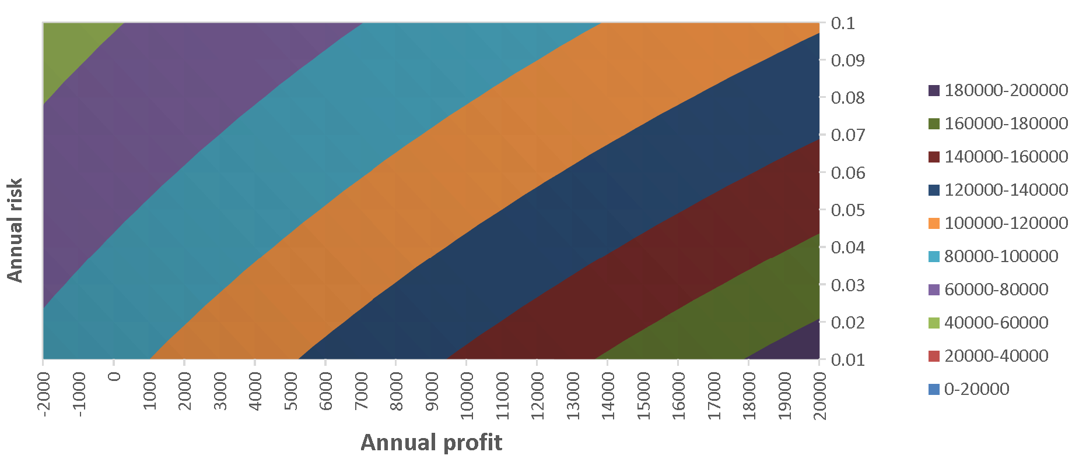

Figure 12.6. The utility function with current investor wealth = 100,000 and time horizon = 5. Utility is highest in the lower right corner, where risk is lowest and profit highest; it is lowest in the upper left corner of the plot.

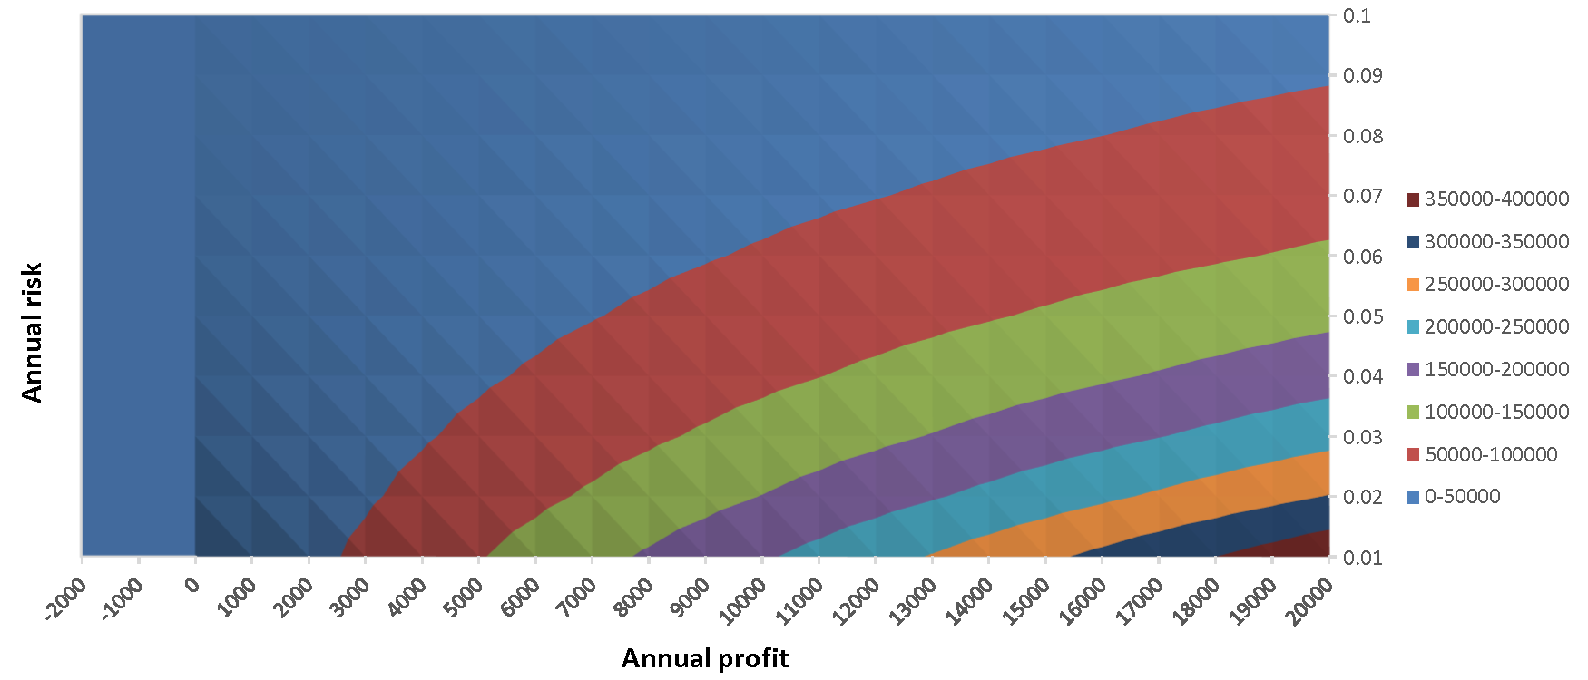

Figure 12.7. Utility function with investor wealth = 0 and time horizon = 25.

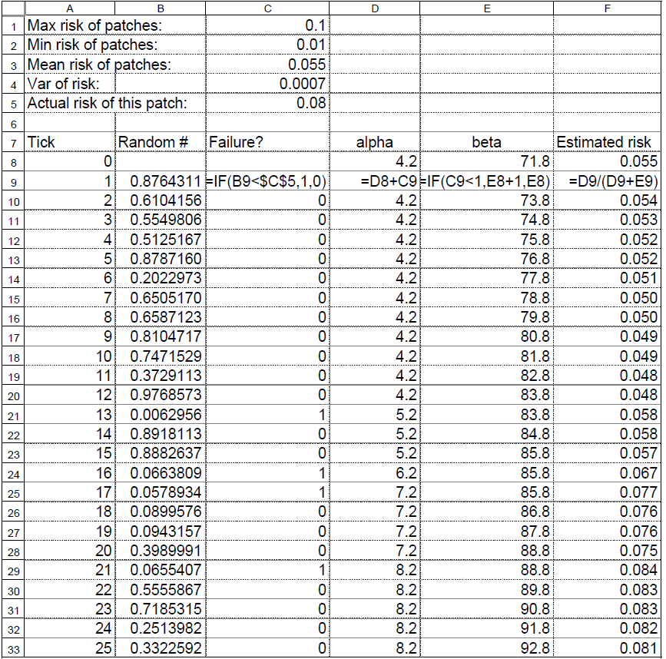

Figure 12.9. Spreadsheet implementation of the Bayesian updating method for estimating risk. This code implements an investor’s estimate of the risk in one patch as the first 25 ticks of a simulation proceed. Notes: The 0 tick (row 8) provides the initial estimate of risk; cells D8 and E8 calculate the initial values of *α* and *β* using the equations shown in the text, where *R* is cell C3 and *V* is cell C4. For subsequent ticks, columns D and E update the values of *α* and *β* using the formulas illustrated in row 9, and column F contains the resulting new estimate of risk. Column B contains random numbers that are compared (in column C) to the patch’s actual risk to determine whether a failure occurs each time step.

# Interaction



Figure 13.1. An implementation of the Telemarketer model. Telemarketers appear on the View as circles; patches are dark if they have not been called and light if they have. The “Business Size Distribution” histogram shows how many telemarketer businesses there are of each size range. “Number of Businesses” shows the number of telemarketers still in business. “Total sales” is the total sales of all marketers on the current time step.

Fig13-2a-VaryNumMarketers Fig13-2b-WeeksInBusiness

Figure 13.2. Example results from the Telemarketer model. Left panel: The number of telemarketers in business over time, for 10 values of the initial number of marketers. Right panel: Median number of weeks that telemarketers stay in business versus initial number of marketers.

Fig13-3_TeleMarketersWithMergers

Figure 13.3. Example results from the Telemarketer model with mergers: compare to the left panel of Figure 13.2.

# Scheduling



Figure 14.1. The Mousetrap model. Patches represent traps and turn black when they have been triggered. The Command Center displays the time (fractional tick) at which each trap is triggered. In this run, the first trap triggered was near the lower right corner.

# 

# Stochasticity

Table 15.1. Observed frequencies of investor decisions.

|  |  |  |  |
| --- | --- | --- | --- |
| Investor alternative | Number of times available | Number of times chosen | Frequency chosen when available |
| Change to investment with higher profit and lower risk | 202 | 162 | 80% |
| Change to investment with higher profit and higher risk | 4830 | 224 | 4.6% |
| Change to investment with lower profit and lower risk | 8340 | 263 | 3.2% |
| Change to investment with lower profit and higher risk | 12174 | 0 | 0% |
| Do not change investments | 12,500 | 11831 | 95% |

# Collectives



Figure 16.1. Example logistic function, relating probability of dog pack reproduction to dog population.



Figure 16.2. Response of extinction frequency in the Wild Dog model to the rate at which pairs of disperser groups meet.

# Introduction to Part III

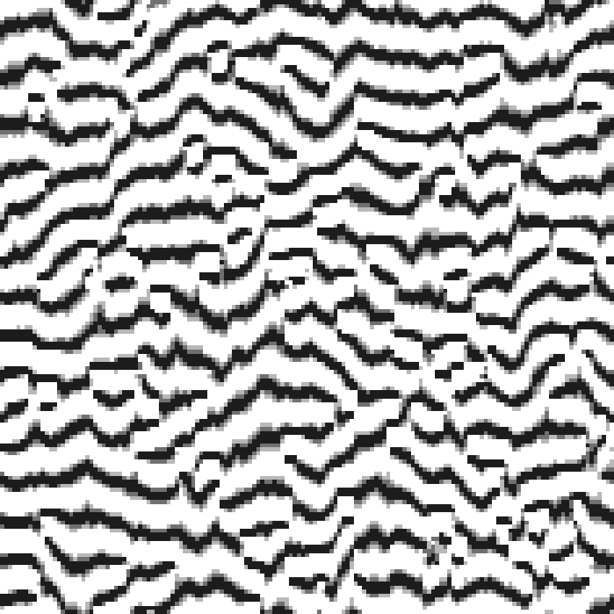

Figure 17.1. Banded vegetation pattern as reproduced by the model of Thiery et al. (1995): bands of shrubs or trees (grey and black) alternate with bands that lack such vegetation (white). This pattern is observed in semi-arid landscapes where water runs off in a uniform direction (here, from top to bottom). (Figure produced from a NetLogo reimplementation by Uta Berger, using File/Export/View from the main menu.)





Figure 17.2 Graphical illustrations of patterns observed in coffee farms and used by Railsback and Johnson (2011) to design an ABM of bird feeding and pest insect control. The patterns are as follows: (top left) the reduction in pest infestation (percentage of coffee berries infested by insects) is higher when the infestation rate is higher; (top right) over a season at specific sites, the change in bird density is positively related to the availability of nonpest food; (bottom left) bird density increases rapidly after a sudden insect outbreak that increases the density of nonpest food; (bottom right) the distribution of distances that birds move within 1 hour follows a log-normal distribution, with many short-medium distance moves and few—but not zero—long moves.

# Patterns For Model Structure

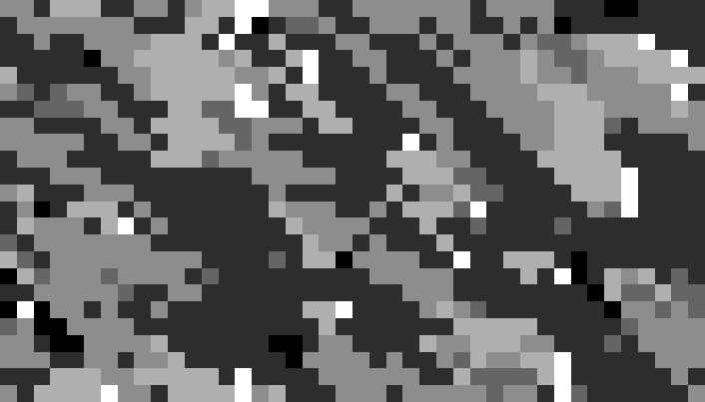

Figure 18.1. View of Wissel’s (1992) beech forest model, from a NetLogo reimplementation by Jan Thiele. The shading represents the time since a cell was empty: cells range from white on the first time step after becoming empty to black at the maximum age of a cell, after which the cell’s old beech tree will die of age.

Fig18-2

Figure 18.2. The four height compartments of a cell in BEFORE. Individual trees of the two highest compartments are represented as individuals, but beech seedlings and juveniles of the lower two compartments are represented only by the percent of the cell covered by them (from Rademacher et al. 2004)

# Theory Development

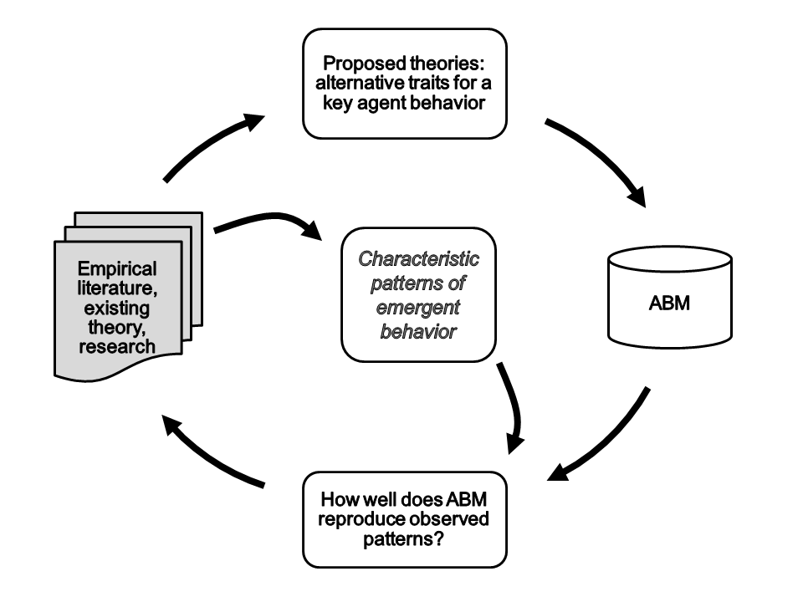

Figure 19.1. The POM cycle for developing theory for an agent behavior. Existing literature on the real system, and sometimes new empirical research, is used to identify patterns that characterize the system behaviors that emerge from the agents’ behavior submodel. The empirical information is also used, along with existing theory, to propose alternative theories for the behavior. The alternative theories are implemented in an ABM and tested by how well the ABM then reproduces the characteristic patterns. Promising theories can be refined by finding or developing more empirical information that provides additional characteristic patterns and suggests improvements to the theory, and then repeating the cycle.



Figure 19.2. Characteristic woodhoopoe group size distribution, illustrated as a NetLogo histogram. The histogram shows how many social groups there were (Y axis) for each number of birds per group (X axis). The distribution includes results at the end of month 12 of each year, over years 3-22 of a 22-year simulation. Only adults (age > 12 months) are counted. The number of groups with zero adults (first bar) is very low, often zero. The number of groups with only 1 adult (second bar) is low, and the number of groups with 2 adults is highest. As the number of adults increases above 2, the number of groups becomes rapidly smaller; here there are no groups with more than 4 adults.

# Parameterization and Calibration

Fig20-1_TimeSeriesCalib

Figure 20.1. Example time series calibration. The black dots show observed data (number of agents) collected annually from 2000 to 2007, with error bars showing the +/- 100 range considered acceptable for calibration. The other symbols represent model results for three different sets of parameter values. The data have a trend of decreasing from 2000 to 2003, then increasing gradually until 2007. Parameter set A produces results that have no clear trend over the eight years; set B has a generally downward trend, and set C has a minimum at 2004.

Table 20.1. Measures of model fit to calibration data for example results in Figure 20.1.

|  |  |  |  |  |
| --- | --- | --- | --- | --- |
| Measure of model fit |  | Parameter set | |  |
| A | | B | C |
| Difference in mean | 36 | | 24\* | 62 |
| Difference in standard deviation | 53 | | 38 | 17\* |
| Maximum error | 296 | | 240 | 158\* |
| Mean squared error | 19712 | | 13976 | 9699\* |
| Number of years with results within 100 units of data | 5 | | 5 | 5 |

\*Lowest value, indicating best fit of model to data.



Figure 20.2. BehaviorSpace experiment for calibration of the woodhoopoe model.

Table 20.2. Example BehaviorSpace Output for Woodhoopoe Model Calibration.

|  |  |  |  |  |  |  |  |
| --- | --- | --- | --- | --- | --- | --- | --- |
| [run number] | scout-prob | survival-prob | [step] | year | month | count  turtles | count patches with [count (turtles- here with [is-alpha?])  < 2] |
| 1 | 0 | 0.95 | 0 | 1 | 0 | 100 | 0 |
| 1 | 0 | 0.95 | 1 | 1 | 1 | 88 | 5 |
| 1 | 0 | 0.95 | 2 | 1 | 2 | 83 | 7 |
| 1 | 0 | 0.95 | 3 | 1 | 3 | 78 | 6 |
| 1 | 0 | 0.95 | 4 | 1 | 4 | 74 | 6 |
| 1 | 0 | 0.95 | 5 | 1 | 5 | 67 | 8 |
| 1 | 0 | 0.95 | 6 | 1 | 6 | 63 | 10 |
| 1 | 0 | 0.95 | 7 | 1 | 7 | 60 | 10 |
| ... |

* Fig20-3_CalibParamSpace

Figure 20.3. Calibration results for the woodhoopoe model example. The plot represents the parameter space: the BehaviorSpace experiment ran the model once for each intersection in the grid. The symbols appear at grid locations where the parameter combination caused the model to meet one of the calibration criteria.

Table 20.3 “Observed” Data for Exercise 2

|  |  |  |
| --- | --- | --- |
| Time step (*t*) | Harvest (*H*) | Observed resource abundance (*N*) |
| 1 | 1141 | 2240 |
| 2 | 1080 | 2410 |
| 3 | 956 | 2460 |
| 4 | 917 | 2630 |
| 5 | 825 | 2360 |
| 6 | 949 | 2590 |
| 7 | 771 | 2460 |
| 8 | 734 | 2690 |
| 9 | 628 | 2580 |
| 10 | 551 | 3060 |
| 11 | 735 | 2600 |
| 12 | 763 | 2460 |
| 13 | 802 | 2460 |
| 14 | 852 | 2350 |
| 15 | 957 | 2640 |

Table 20.4 Alternative Parameter Sets for Exercise 2

|  |  |  |  |
| --- | --- | --- | --- |
| Parameter | Value for parameter set: | | |
| 1 | 2 | 3 |
| *R* | 1.95 | 1.5 | 2.2 |
| *K* | 3050 | 3320 | 2950 |
| *N0* | 2250 | 2400 | 2200 |

# Introduction to Part IV

# Analyzing and Understanding ABMs

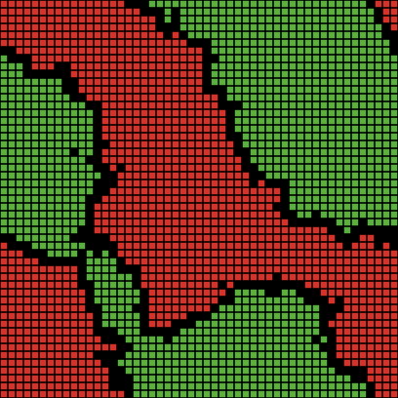

**Figure 22.1. Example Segregation model results with *%-similar-wanted* = 75% and household density = 90%.**

Table 22.1. Currencies for model analysis used in this book.

|  |  |  |
| --- | --- | --- |
| Model | Currencies | Chapter; location |
| Butterfly Hilltopping | Corridor width  Final clumping of butterflies | 5; figs. 5.2, 5.3  5; exercises 5 and 6 |
| Culture Dissemination | Mean similarity of sites with neighbors | 6; section 6.5.1, exercise 7 |
| Simple Birth Rates | Time to extinction | 8; fig. 8.3 |
| Flocking | Number of turtles who have flockmates  Mean number of flockmates per turtle  Mean distance between a turtle and its nearest neighbor  Standard deviation in heading | 8; figs. 8.5, 8.6 |
| Business Investor | Mean annual profit and risk of investors  Mean investor wealth  Mean final wealth of investors  Number of failures | 10; fig. 10.1  11; figs. 11.1, 11.2 |
| Telemarketer | Number of telemarketers in business  Median weeks in business  Business size distribution  Total sales | 13; figs. 13.2, 13.3 |
| Mousetrap | Number of balls in the air | 14; fig. 14.1 |
| Wild Dogs | Frequency of extinction within 100 years | 16; fig. 16.2 |
| Woodhoopoes | Shape of the group size distribution  Mean number of birds  Standard deviation among years in number of birds  Mean percentage of territories vacant | 19; fig. 19.2  20; fig. 20.3 |
| Segregation | Time steps until stasis  Size and shape of homogeneous areas | 22; section 22.2.2 |

Fig22-2_RammigFahseScenario

**Figure 22.2. The use by Rammig and Fahse (2009) of an unrealistic scenario to analyze the importance of local interactions in a forest model. The black cell illustrates how all cells are simulated. In the normal version of the model (left panel), the state of a cell is determined by its eight neighboring cells. In the unrealistic scenario (right panel), the state of a cell is determined by eight randomly chosen cells.**

**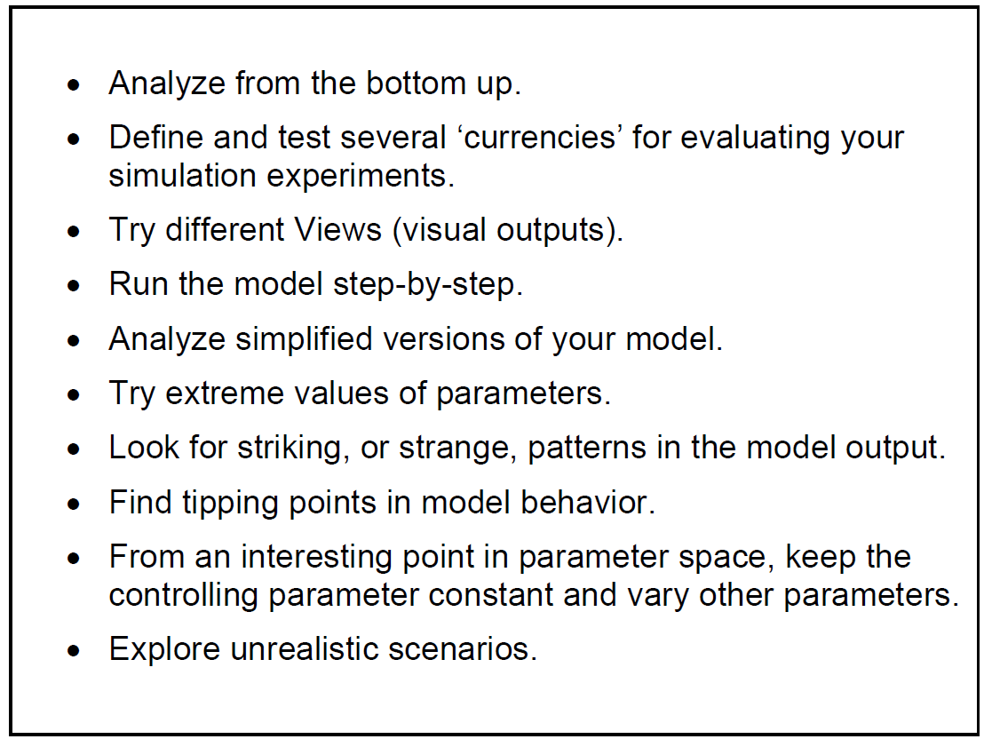**

**Figure 22.3. Heuristics of model analysis.**

# Sensitivity, Uncertainty, and Robustness Analysis

Table 23.1. Single-Parameter Sensitivity Analysis of the Wild Dog Model for Four Example Parameters

|  |  |  |  |  |  |
| --- | --- | --- | --- | --- | --- |
| Parameter | Standard value | Minimum, step, maximum value\* | Regression statistics | | |
| Slope | R2 |  |
| disperser-meet-rate | 1.0 | [0.5 0.075 2.0] | -0.10 | 0.35 |  |
| disperser-merge-prob | 0.64 | [0.32 0.032 0.96] | -0.13 | 0.54 |  |
| mort-pup | 0.12 | [0.096 0.0024 0.144] | 0.00 | 0.00 |  |
| mort-adults | 0.2 | [0.16 0.004 0.24] | 0.30 | 0.86 |  |

\*This column uses NetLogo’s BehaviorSpace format for defining the parameter values in a simulation experiment.



Figure 23.1. Results of the Wild Dog model sensitivity analysis.

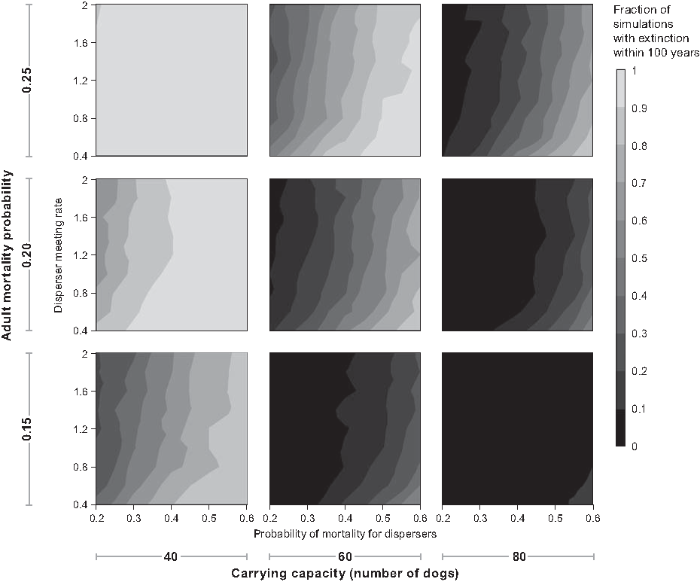

Figure 23.2. Contour plots arranged to visualize sensitivity of the Wild Dog model to four parameters. Each of the nine panels is a contour plot showing how the model currency (fraction of simulations in which the dog population went extinct within 100 years) varies with the annual mortality probability for disperser dogs (x-axis) and the mean number of times disperser groups meet per year (y-axis). Each row of panels includes subplots from model runs with the parameter for habitat carrying capacity set to 40, 60, and 80. Each column includes subplots from runs with the adult mortality probability set to 0.15, 0.2, and 0.25.





Figure 23.3. Uncertainty analysis results for the Wild Dog model; the histograms show how many simulation experiments out of 1000 (y-axis) produced extinction frequency results within the ranges shown on the x-axis. With the standard parameter values (upper panel), the frequency of extinction was between 0.05 and 0.15 in almost all of the 1000 simulation experiments. With probability parameter values drawn from random distributions (lower panel), results varied widely over the 1000 experiments, with extinction frequencies between 0.0 and 0.35 common.

# Where To Go From Here

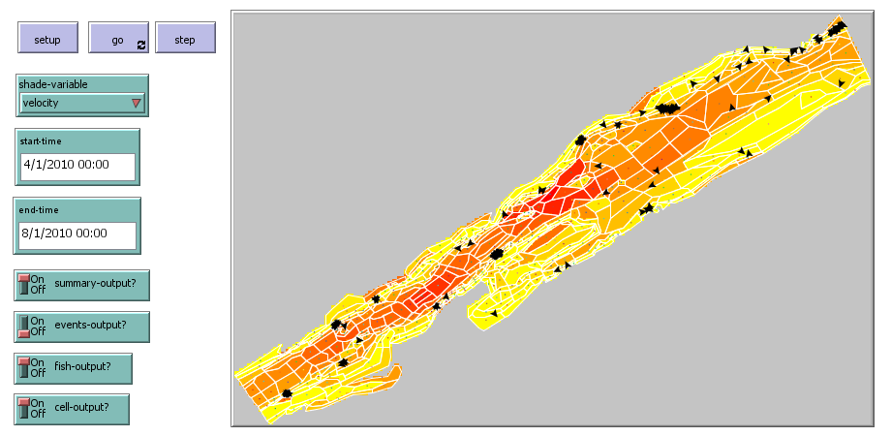

Figure 24.1. NetLogo interface of an unpublished river fish ABM that represents space as irregular polygonal cells. The cell boundaries are imported using the GIS extension. A breed of turtle holds the state variables for the cells; one such turtle is placed at the center of each polygon. NetLogo’s patches determine their characteristics (e.g., pcolor) from the polygon they are in. This model also uses the Time extension to relate NetLogo’s ticks to specific time units (here, each tick represents 2 hours, and the model runs from April 1 through July 31, 2010)